##### PROJECT REPORT

on

**Material Characterization Using Microwave Sensor Array and Machine Learning**

###### ***Submitted by***

##### Nikhil Kumar

**Shambhavi Priya**

**Sonika Yadav**

**Uddeshya Kumar**

**Adersh Ramesh**

***in partial fulfillment of requirement for the award of the degree***

***of***

##### BACHELOR OF TECHNOLOGY

**in**

**ELECTRONICS AND COMMUNICATION**

**DIVISION OF ELECTRONICS ENGINEERING**

**SCHOOL OF ENGINEERING**

**COCHIN UNIVERSITY OF SCIENCE AND TECHNOLOGY**

**KOCHI-682022**

**MAY 2022**

DIVISION OF ELECTRONICS ENGINEERING

SCHOOL OF ENGINEERING

COCHIN UNIVERSITY OF SCIENCE AND TECHNOLOGY

KOCHI-682022

**CERTIFICATE**

*Certified that the report entitled* ***“Material Characterization Using Microwave Sensor Array and Machine Learning”*** *is a bonafide work of* ***Nikhil Kumar, Shambhavi Priya, Sonika Yadav,Uddeshya Kumar and Adersh Ramesh*** *towards the partial fulfillment for the award of the degree of B.Tech in Electronics and Communication of Cochin University of Science and Technology, Kochi-682022.*

**Project Guide Head of the Division**

**(Dr. Mridula S) Dr. Anju Pradeep**

**ACKNOWLEDGEMENT**

We would like to take this opportunity to express our gratitude to everyone who helped us complete the project successfully. First and foremost, we wish to thank our guide, Dr. Mridula S for believing in us and thereby giving us the confidence to pursue a project in microwaves and machine learning. Her constant motivation, guidance, suggestions and advices helped us cross one obstacle after the other and propelled us to work harder and do better. Her words of appreciation from time to time worked as little trophies for us that pushed us to maintain the pace and quality of our work. Her most priceless gift to us was in the form of our second guide, MrsThushara P. We could not be thankful enough to be so lucky so as to have Thushara ma’am’s guidance and expertise for this project. She supported us every step of the way. Be it late night discussions or early morning messaging, she truly stood by us day and night and gave us her precious time whenever we needed it. Lastly, we wish to thank our parents for their unconditional love, support and care that always keeps us going.

Nikhil Kumar

Shambhavi Priya

Sonika Yadav

Uddeshya Kumar

Adersh Ramesh

**ABSTRACT**

Accurate measurement of material properties has gained considerable importance over the last decade. The ability to non-destructively monitor specific properties of a material has led to many applications in industry, medicine and pharmaceuticals. The measurement methods relevant for any desired application depends on the nature of the dielectric material to be measured, both physically and electrically, the frequency of interest, and the degree of accuracy required. Recently, a new and alternative sensing platform using the concept of metamaterials has been introduced. The metamaterials are being investigated for use in material sensing in a very broad spectral range, including microwaves, terahertz, and optics. Metamaterial studies have been done to characterize complex dielectric permittivity that contains complete information on the dielectric constant and loss tangent of the samples.

In our project, we present a microwave sensor array with the five resonating elements of the array operating at different frequencies covering a wide bandwidth. This allows for taking the advantage of excellent sensitivity of high quality factor (Q) resonators while, similar to TL approach, collecting information over a wide bandwidth (at multiple frequencies within the band). Also, the presented sensor array is based on metamaterial-inspired resonators. Furthermore, machine learning is applied on the data collected to predict an accurate range of permittivity of the material under test. The advantages of the proposed material identification system include its compactness, low cost, and low error rate, and its contactless, reusable, easy-to-fabricate, and easy-to-work operation.

**CONTENTS**

List of Tables i

List of Figures ii

List of Abbreviations iv

1. **Introduction** 1

1.1 Electromagnetic Metamaterials 1

1.1.1 Metamaterial Structural Elements 1

1.2 Types of metamaterial for microwave sensing 2

1.2.1 Split Ring Resonator (SRR) 2

1.2.2 Complimentary Split Ring Resonator (CSRR) 2

1.3 Material Characterization 3

1.3.1 SRRs and CSRRs for sensor design 3

1.4 Microwave sensor array and machine learning 5

**2. Literature Review** 6

**3. Sensor Array Design** 7

3.1 Reference paper review 7

3.2 Compact Sensor Array 9

3.3 Comparison 11

**4. Machine Learning** 13

4.1 Dataset generation 13

4.2 Machine Learning 14

4.2.1 Methodology 14

4.3 Results 15

4.3.1 Regularization 18

**5. Conclusion and Future Scope** 20

**References** 21

**LIST OF TABLES**

|  |  |  |
| --- | --- | --- |
| TABLE NO. | DESCRIPTION | PAGE NO. |
| 3.1 | Dimensions of the designed CSRR | 8 |
| 3.2 | Comparison of base paper resonant frequencies vs. simulated frequencies | 9 |
| 3.3 | Dimensions of the sensor array | 10 |
| 3.4 | Distance between CSRRs as shown in Figure 3.5 | 11 |
| 4.1 | Performance metrics for each regression model | 17 |
| 4.2 | Overall prediction performance metrics | 18 |

i

**LIST OF FIGURES**

|  |  |  |
| --- | --- | --- |
| FIG. NO. | DESCRIPTION | PAGE NO. |
| 1.1 | Metamaterial concept | 2 |
| 1.2 | Schematic layout of classical (a) SRR and (b) CSRR | 3 |
| 1.3 | Behavior of CSRR and SRR sensors for permittivity change in the surrounding medium | 4 |
| 1.4 | Example of a CSRR and its equivalent circuit model | 4 |
| 3.1 | Sensor array back surface | 8 |
| 3.2 | Parametric model of each CSRR | 8 |
| 3.3 | Frequency vs. S21 plots: (a) as given in the base paper, (b) as obtained from simulation | 9 |
| 3.4 | Dimensions of compact array | 10 |
| 3.5 | Final design (back surface) | 10 |
| 3.6 | Final S-parameter |S21| | 11 |
| 3.7 | Comparison between the base design and modified design | 12 |
| 4.1 | Shift in S21 parameters for various MUTs: (a) Arlon AD 320A, (b) PTFE, and (c) Rubber | 13 |
| 4.2 | Total prediction accuracy. (a) Linear Regression, (b) Random Forest, and (c) Decision Tree | 14 |
| 4.3 | Overall prediction performance using voting regressor | 17 |
| 4.4 | Performance vs. regularization parameter | 18 |
| 4.5 | Train error vs. test error | 19 |
| 4.6 | Overall model performance | 19 |

ii

**LIST OF ABBREVIATIONS**

1. SRR Split Ring Resonator
2. CSRR Complimentary Split Ring Resonator
3. MUT Material Under Test

iii

**CHAPTER 1**

**INTRODUCTION**

Microwave sensors have gained importance in many research areas such as biomedical and chemical mainly due to its high sensitivity, robustness, and low cost. Recently, a new and alternative sensing platform using the concept of metamaterials has been introduced. Metamaterials (meta means “beyond” in Greek) are new artificial materials with unusual electromagnetic properties that are not found in naturally occurring materials.

**1.1 Electromagnetic Metamaterials**

All “natural” materials such as glass, diamond and such have positive electrical permittivity, magnetic permeability, and an index of refraction. In these new artificially fabricated materials—termed as negative index materials (NIM) or left-handed (LH) materials—all these material parameters are negative. Due to such unique properties metamaterials have various applications, starting from perfect lenses and invisible cloaks, antennas, and different types of sensors.

**1.1.1 Metamaterial structural elements**

The first metamaterial was fabricated by interleaving SRRs and copper wires. The experiment used a 2-D array of repeated unit cells of copper strips and split ring resonators (SRR) on interlocking strips of standard circuit board materials. In such metamaterials, an array of SRRs contributes to the negative µ; the copper wire array contributes to the negative ε and the combined array results in a negative permeability and permittivity material.

Nowadays, a multitude of metamaterials structural element types are known. In most cases, metamaterials consist of a periodical lattice of identical elements (or sets of elements), being analogy to crystals, as showed in Fig.1.1. The constitutive elements of a metamaterial are named meta atoms or meta molecules. Some of them are wire meshes, splitter ring resonators, conical Swiss rolls, Swiss rolls etc. In principle, the structural elements of metamaterials might be classified into two categories: those with negative dielectric permittivity and, in a certain frequency range, those with negative magnetic permeability or very high magnetic permeability, although the elements are made from paramagnetic materials.

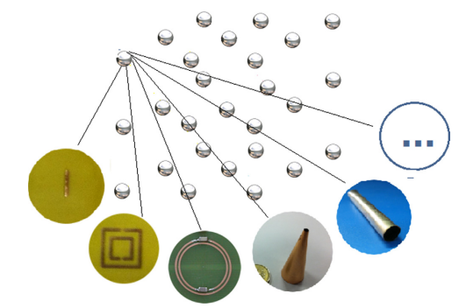

Figure 1.1: Metamaterial concept

**1.2 Types of metamaterial elements for microwave sensing**

The main part of the metamaterial-based microwave sensors are split-ring resonators (SRR) or complementary split-ring resonators (CSRR), fabricated using various techniques such as microstrip and thin film. The CSRRs and SRRs can exhibit a well-established electric field along the metamaterial structure, which is sensible to dielectric materials placed close to it, producing changes in the resonant frequency and Q-factor of the electric field.

**1.2.1 Split Ring Resonator (SRR)**

This type of metamaterial has the advantage to be planar, such that its practical realization can be made via photo-lithography for relatively large dimensions and nanolithography for nanometric dimensions. SRR is the most popular negative permeability metamaterial structure. It basically consists of a ring resonator with a slit. The slit is introduced to break the closed loop of induced current around the ring when an axial magnetic field is acting upon it.

**1.2.2 Complementary Split Ring Resonator (CSRR)**

We know that the SRRs can inhibit signal propagation in a band in the vicinity of its resonant frequency when are excited by a time-varying magnetic field component in its axial direction. The CSSR is the counterpart of the SRR and, therefore, the CSRRs require a time-varying electric field excitation having a component parallel to its axis.

Figure 1.2: Schematic layout of classical (a) SRR and (b) CSRR

**1.3 Material characterization**

The response of a material to electrical signals depends on the permittivity of materials. Thus, precise determination of the permittivity is an important task for microwave/radio-frequency circuit design and antenna design. Many methods have been proposed and used for material characterization. These methods can be classified as free-space methods, transmission-line methods, near-field sensors, and resonant cavity methods.

One of the applications of microwave sensing is in material identification, the sensing part of a microwave material characterization system is constructed using either a single resonator or a transmission line (TL). In single-resonator sensors, the high-quality factor (Q) of these devices renders the resonance frequency change due to the exposure to the material under test (MUT) measurable. However, this high sensitivity is only over a limited frequency band. If the tested MUTs have similar properties over the resonance band, they cannot be distinguished well. Whereas transmission-line-based sensors are suitable for broadband sensing with reduced sensitivity. So, there is a trade-off between the sensitivity and the bandwidth to achieve broadband sensing.

**1.3.1 SRRs and CSRRs for Sensor Design**

In such resonators, the capacitance of the current path has direct dependence on the permittivity of the medium, and the inductance of the current path has direct dependence on the permeability of the medium. Since CSRRs are excited by an electric field polarized in the direction normal to the plane of the resonator, the CSRRs are more sensitive to the permittivity of the medium. Analogously, SRRs are more sensitive to the permeability of the medium. Fig. 1.3 shows the resonance frequency shift of the CSRR and SRR structures as a function of the permittivity of the medium. The relative resonance frequency shift is calculated with respect to the resonance frequency when the medium is vacuum. CSRR sensor experiences a higher resonance frequency shift as the permittivity changes.

Figure 1.3: Behavior of CSRR and SRR sensors for permittivity change in the surrounding medium [2]

The CSRRs and SRRs demonstrate a quasi-static resonance, which allows an equivalent circuit model to be built. The SRRs and CSRRs have advantages over the conventional microwave resonator since they can resonate with a much smaller size, present low radiation losses, and have very high quality factors. Both resonators provide good stable frequency response but CSRRs are used most for sensor design as they can be centred on the ground plane having the transmission line in the other face. Doing this, the sample can be placed in the centre of resonator and transmission line. This is an important feature, since the uniformity of the field in the sample is expected to be close to theoretical ones. Moreover, the CSSR sensor does not need extra circuit area, making the proposed sensor more compact.

Figure 1.4: Example of a CSRR and its equivalent circuit model [3]

The equivalent circuit model for the squared CSRR cell is showed in the Fig. 1.4. When a microstrip transmission line is fed by a microwave signal, it excites the CSRR by inducing a voltage difference between the capacitive plate of CSRR and the ground plane. Consequently, the resonance occurs when the stored electric energy in the CC and Cr capacitors equals to the magnetic energy in inductive microstrip Lr. During the resonance, an electric field is established across the gap between the CSRR capacitive plate and the squared resonator making the region near and inside of CSRR sensitive to dielectric changes. Therefore, it is possible to use this region inside of the CSRR to measure dielectric properties of materials.

**1.4 Microwave Sensor Array and Machine Learning**

Microwave sensing has been utilized over the past decade for a broad area of applications from noise measurement systems and spatial displacement measurement to single-cell viability detection and material characterization. The elements of the array resonate at different frequencies, covering a wide band. This allows us to benefit from the excellent sensitivity of the high-Q resonators while, like the TL approach, collecting information over a wide bandwidth. In our project, we present a compact microwave sensor array of five resonator sensors operating at different frequencies covering a wide bandwidth. These resonating elements are based on a microstrip transmission line loaded with CSRRs designed at different frequencies within the range of 1GHz to 10GHz. The performance of this sensor array is evaluated via simulations with different materials.

Furthermore, we apply machine learning to the collected data to predict the real part of permittivity range of the material under test.

**CHAPTER 2**

**LITERATURE REVIEW**

The backbone of our project is based on the paper titled “Material Identification using Microwave Sensor Array and Machine Learning” by Luke Harrison et al. This paper is referred as our base paper throughout this report. The main premise of our project is based on implementing the microwave sensor array as given in the base paper, learning from the results obtained and finally modifying the design to make it more compact. During the course of the project, the main objective of our work changed from material identification to material characterization for permittivity prediction using compact sensor array and machine learning.

A thorough literature review was undertaken to enable an overall understanding of the various aspects involved in sensor array design.

In [2], a metamaterial based microwave sensor with a CSRR was implemented for dielectric characterization of liquids. An overall review of the CSRR structure design and theoretical study was presented in great detail. This helped us gain a better understanding of CSRR properties, electrical characteristics and design parameters. The liquid samples inside the glass capillary tubes modify the resonant frequency and Q factor of the CSRR sensor. Thereby a relation between the sensor resonant frequency, Q factor, and complex permittivity of the liquid samples was estimated.

In [3], microwave non-invasive planar sensor based on the complementary split ring resonator (CSRR) was proposed for accurate measurement of the complex permittivity of materials. The CSRR was etched in the ground plane of the planar microstrip line. The paper compared rectangular and circular cross sectional CSRRs in terms of their sensitivity to sensing. The electric field induced along the plane of CSRR at resonance, was found to be quite sensitive for the characterization of specimen kept in contact with the sensor.

In [4], a microwave sensor array based on -ve compact CSRRs for water quality testing was presented. The sensor elements operated at different frequencies covering a wide frequency band from 1 GHz to 10 GHz. The dielectric properties of the water sample with different contaminants and parameter values were measured.

Several other papers and relevant literature were referred from time to time that propelled the completion of this project.

**CHAPTER 3**

**MICROWAVE SENSOR ARRAY**

**3.1 SENSOR ARRAY IMPLEMENTATION OF BASE PAPER**

In this section, we review the design of the microwave sensor array as given in the reference paper [1]. The array is composed of five resonating elements, as shown in Figure 3.1. These resonating elements are based on a micro strip transmission line loaded with CSRRs designed at different frequencies within the range of 1 GHz to 10 GHz. The use of planar CSRR sensors offers several advantages such as low cost, portability, noninvasiveness, and flexibility of sample preparation. This is why they have been widely used for sensing applications.

The sensor array in Figure 3.1 allows for measuring changes in dielectric properties over a wide frequency range from 1 GHz to 10 GHz, specifically designed to operate at five frequencies, viz. 1 GHz, 3 GHz, 5 GHz, 7 GHz, and 9 GHz. Changes in the dielectric properties can then be monitored through measuring the resonance frequency shifts for the resonator array.

This design of the sensor array was implemented in CST STUDIO SUITE software. The sensor array was designed on a Rogers RO4350B substrate with dielectric properties of εr = 3.66 and tan δ = 0.0031. The width Ws, length Ls, and thickness of the substrate are 20 mm, 56 mm, and 0.75 mm, respectively. The micro strip line was designed to have a characteristic impedance of 50 Ω. This corresponds to the width of strip line being Wm = 1.68 mm. This strip line was placed at the center of the front surface of the substrate. On the back side of the substrate, the five CSRRs were etched out of the ground plane. The CSRRs, as shown in Figure 3.1, were named Sensor 1 to Sensor 5 from left to right and correspond to resonance frequencies of 1.36 GHz, 3.09 GHz, 5 GHz, 6.82 GHz, and 8.91 GHz. Figure 3.2 shows the parametric model for each CSRR structure, including the length of the outer ring L, width of the rings W, the track width between adjacent rings b, and the width of narrow lines a. Table 3.1 shows the optimal design parameters for each sensor. After implementing the design as given in the reference paper, comparable S21 parameters were obtained with little deviation from the designed resonant frequencies.

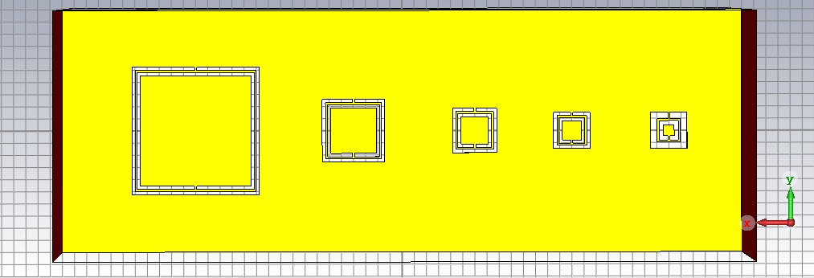

Figure 3.1: Sensor array back surface with Sensor 1 to Sensor 5, shown from left to right

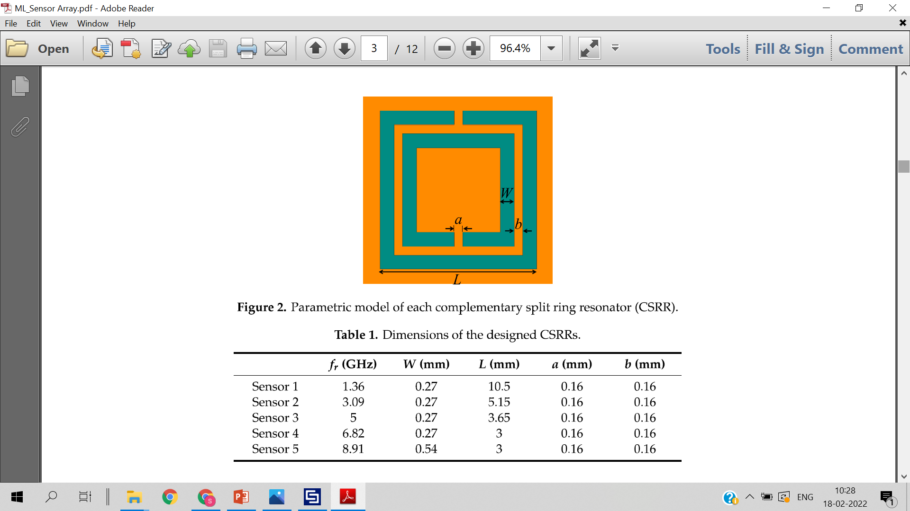

Figure: 3.2: Parametric model of each CSRR

Table 3.1: Dimensions of the designed CSRR



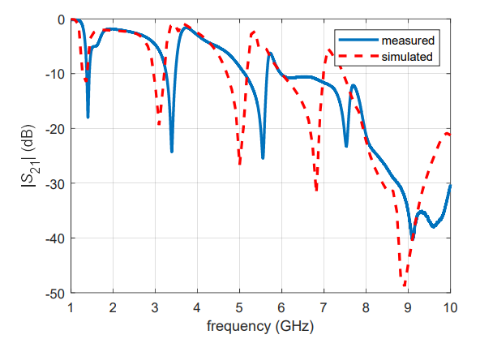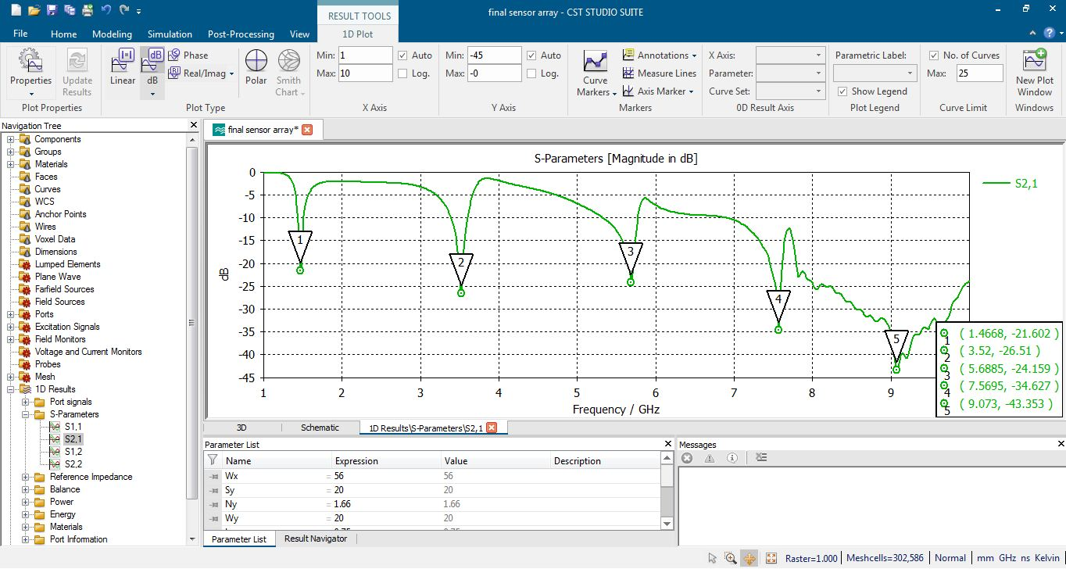

3.3(b)

3.3 (a)

Figure 3.3: Frequency vs. S21 plots: (a) as given in the base paper, (b) as obtained from simulation

Table 3.2: Comparison of base paper resonant frequencies vs. simulated frequencies

|  |  |  |
| --- | --- | --- |
| **Sensor** | **fr ( Base Paper)** | **fr (Simulated)** |
| 1 | 1.36 | 1.46 |
| 2 | 3.09 | 3.52 |
| 3 | 5 | 5.68 |
| 4 | 6.82 | 7.56 |
| 5 | 8.91 | 9.07 |

Figure 3.3 shows a comparison of S21 results as given in the paper and the results obtained through simulation. Table 3.2 shows the comparison between the resonant frequencies as given in the paper and the simulated frequencies for all five sensors.

**3.2 COMPACT SENSOR ARRAY**

After implementing the sensor design as given in the paper, modifications were made to the existing design so as to get a more compact array with similar S21 results. It is important to note that by reducing the distance between the sensors, the electric field associated with the sensors can interact with each other and affect their resonant frequencies. Therefore, an optimum arrangement of sensors was found by trying various arrangements and observing the changes in the S21 parameters. Figure 3.4 and Figure 3.5 show the front side and the back side of the modified sensor array design respectively. Table 3.3 and Table 3.4 list the dimensions of the final substrate and inter element spacing of the final compact sensor array respectively. Figure 3.6 shows the S-parameters for the modified sensor design.

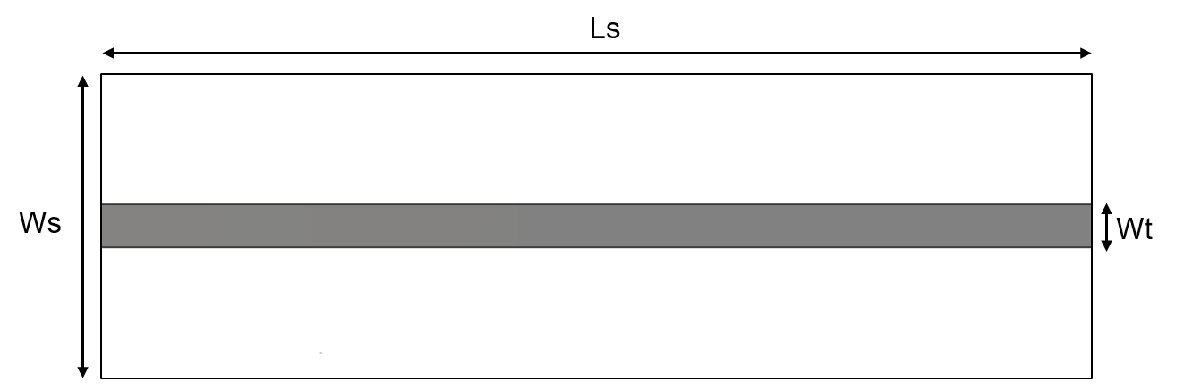

Figure 3.4: Dimensions of compact array

Table 3.3: Dimensions of the sensor array

|  |  |
| --- | --- |
| Dimension | Value (mm) |
| Ls | 27 |
| Ws | 12 |
| Wt | 1.68 |
| Thickness of substrate | 0.75 |

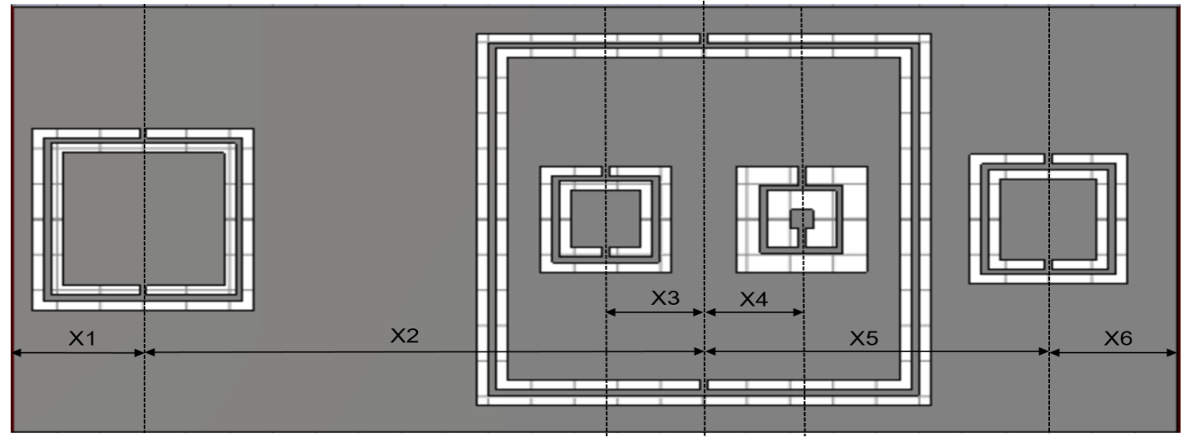Figure 3.5: Final design (back surface)

Table 3.4: Distance between CSRRs as shown in Figure 3.5

|  |  |  |  |  |  |
| --- | --- | --- | --- | --- | --- |
| X1 | X2 | X3 | X4 | X5 | X6 |
| 3mm | 14mm | 1.575mm | 2.275mm | 8mm | 2mm |

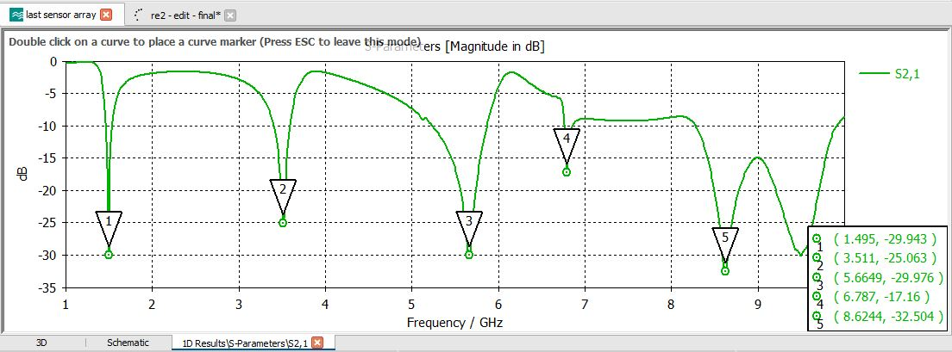

Figure 3.6: Final S-parameter |S21|

There is a total area reduction of 71% from the sensor array given in the base paper with comparable S parameters result.

**3.3 COMPARISON**

Figure 3.7 shows an overall comparison between the base design and the modified design of the sensor array. In order to achieve comparable S21 parameters with an appreciable area reduction, symmetry in the arrangement of CSRRs was compromised.

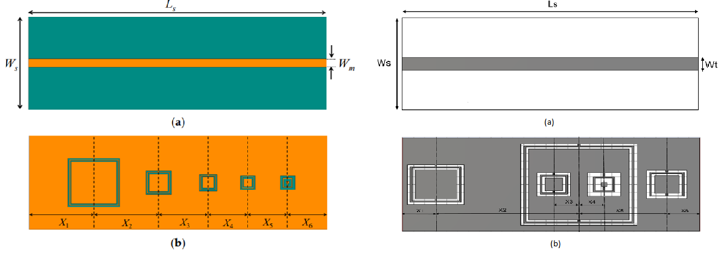

|  |  |
| --- | --- |
| Dimension | Value (mm) |
| Ls | 56 |
| Ws | 20 |
| Wt | 1.68 |
| Thickness of substrate | 0.75 |

|  |  |
| --- | --- |
| Dimension | Value (mm) |
| Ls | 27 |
| Ws | 12 |
| Wt | 1.68 |
| Thickness of substrate | 0.75 |

|  |  |  |  |  |  |
| --- | --- | --- | --- | --- | --- |
| X1 | X2 | X3 | X4 | X5 | X6 |
| 11mm | 13mm | 10mm | 8mm | 8mm | 6mm |

|  |  |  |  |  |  |
| --- | --- | --- | --- | --- | --- |
| X1 | X2 | X3 | X4 | X5 | X6 |
| 3mm | 14mm | 1.575mm | 2.275mm | 8mm | 2mm |



Figure 3.7: Comparison between the base design and modified design

**CHAPTER 4**

**MACHINE LEARNING**

**4.1 Dataset Generation**

In our base reference paper, the authors have used machine learning to classify materials under test (MUTs) into three categories namely, plastic, cardboard and wood. For this classification, fabrication of the sensor array and physical measurement of the samples is a must. Due to limited availability of fabrication facility, fabricating the sensor array was not feasible. Software simulations were therefore performed to build the dataset.

The microwave sensor array was simulated with a random set of materials from the CST library to observe the changes in the S21 parameters. Fig 4.1 shows shift in S21 parameters for a few MUT samples, namely Arlon AD 320A (εr = 3.2), PTFE (εr = 2.1) and Rubber (εr = 3).

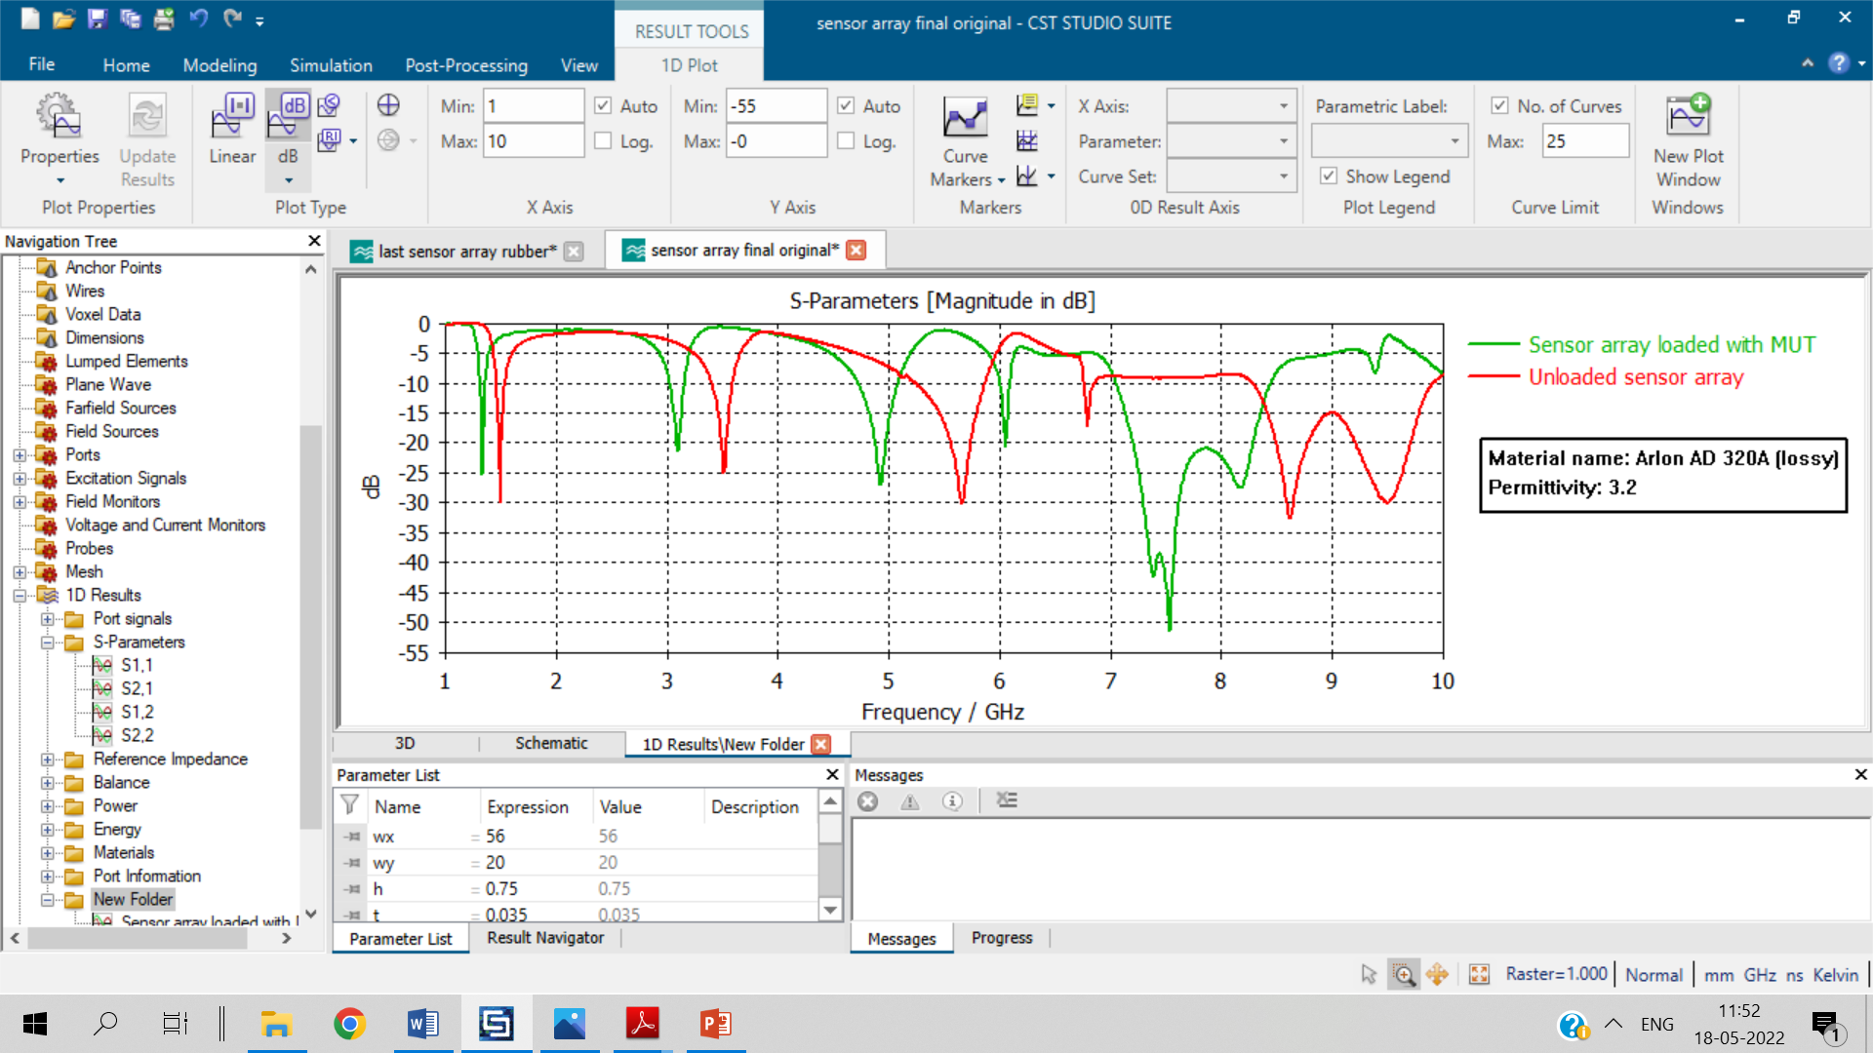

(a)

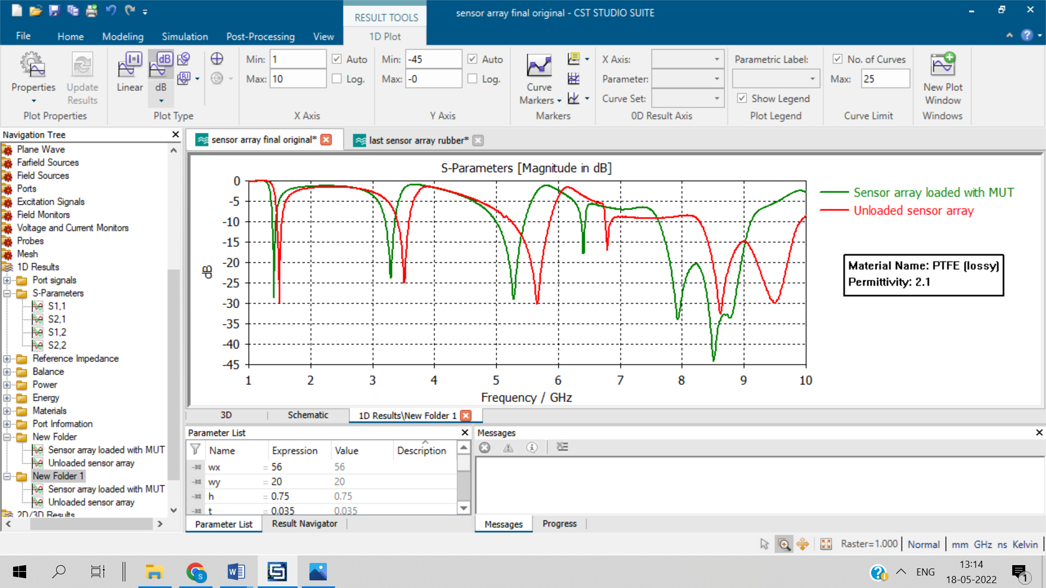

(b)

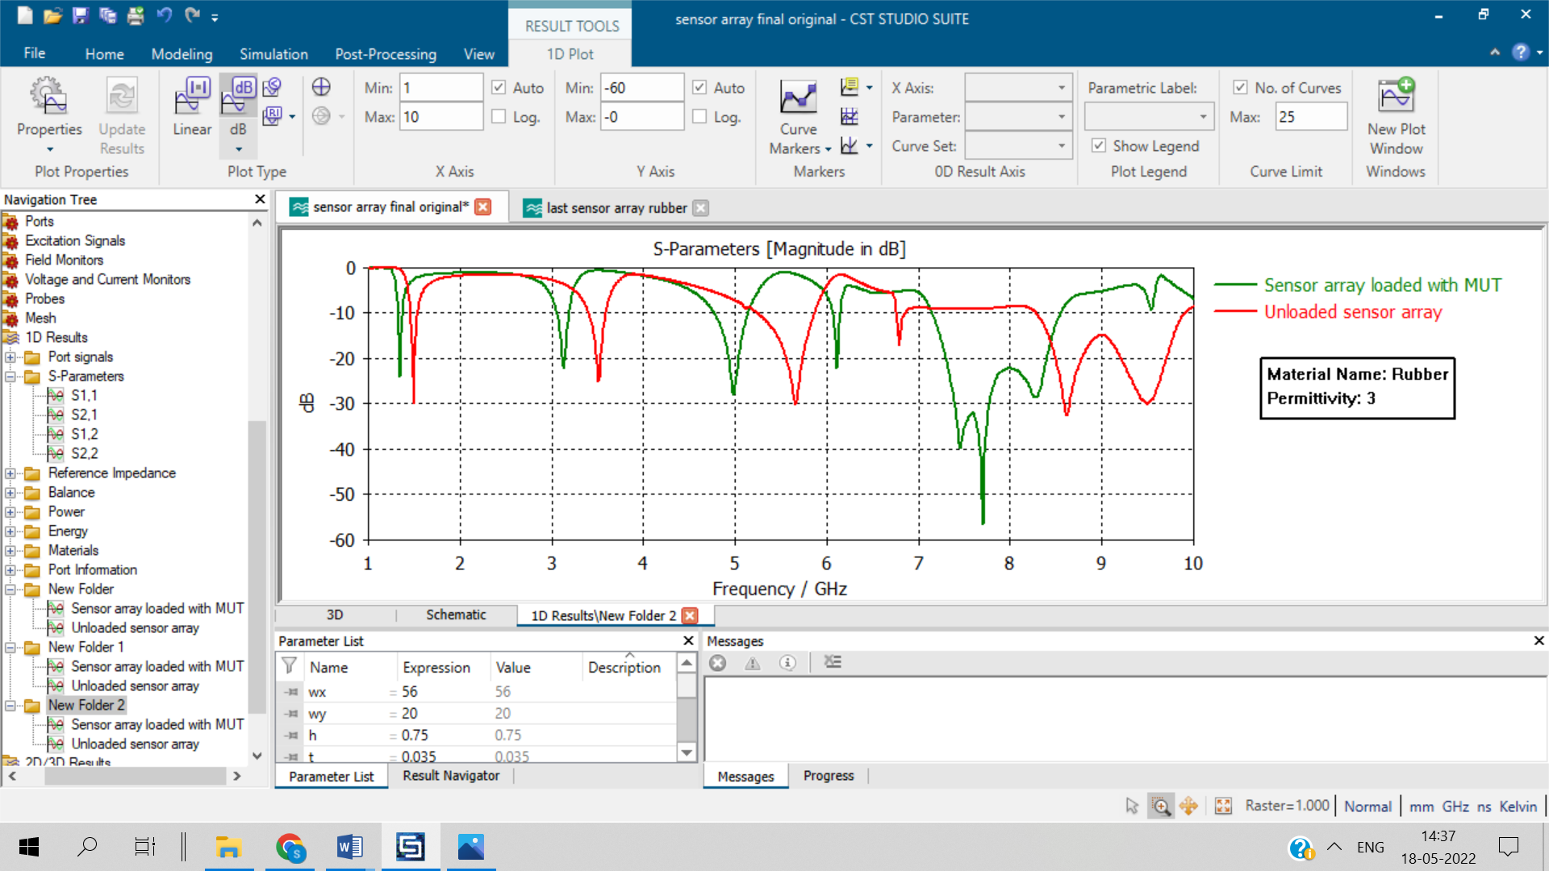

(c)

Figure 4.1: Shift in S21 parameters for various MUTs: (a) Arlon AD 320A, (b) PTFE, and (c) Rubber

The permittivity of the MUT as well as the shifts in the resonant frequencies of all the five sensors were noted. The process of curve fitting was performed on the simulated data and linear regression was found to give the best R2 value for the fitted curve. Eventually, a total of 100 data points were generated by performing linear regression on all the five sensors. In the resulting dataset, 20% of the data is from simulations performed in CST whereas 80% is the data generated using linear regression.

In the next, step random percentage errors were introduced in the data so as to resemble physical measurements as closely as possible. Both positive and negative percentage errors in the range of 5% to 25% were randomly distributed throughout the data. This final dataset was used for performing machine learning algorithms.

**4.2 MACHINE LEARNING**

Machine learning was applied on the collected data to predict the permittivity of the material based on the shifts in the five resonant frequencies in the S21 response due to exposure to the MUTs. The aim was to predict an indicative range of permittivity value of the MUT.

**4.2.1 Methodology**

1. A combination of linear and non-linear regression algorithms were used.
   1. Dependent Variable: Real part of permittivity. Range : 1.5-12.2
   2. Independent Variable: Shift in resonant frequency of five sensors
2. Linear Regression, Random Forest Regressor, and Decision Tree Regressor were used to predict the discrete value of real part of permittivity based on the training and testing set of the data.
3. Results obtained from these three regression algorithms are then combined to form an indicative range for the permittivity (real part).

**4.3 RESULTS**

In this section, we evaluate the performance of the approach in predicting the permittivity range of MUTs. After data pre-processing, the model was trained on each of the three regressors, linear, random forest and decision tree. Stratified k-fold cross-validation procedure was used to evaluate the performance of the models on the test set. Figure 4.2 shows the actual permittivity vs. predicted permittivity of each of the three models. The dotted line indicates the actual permittivity values in the range of 1.5 to 12.2 and the dots scattered around the straight line indicate the predicted value corresponding to each of the hundred actual permittivity points. Table 4.1 shows performance metrics for each regressor.

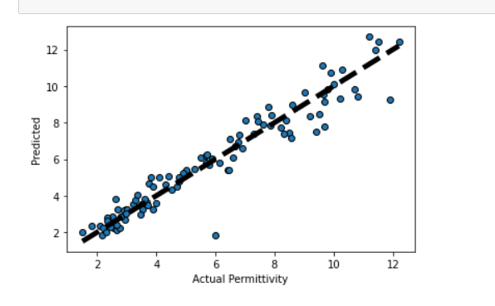

(a)

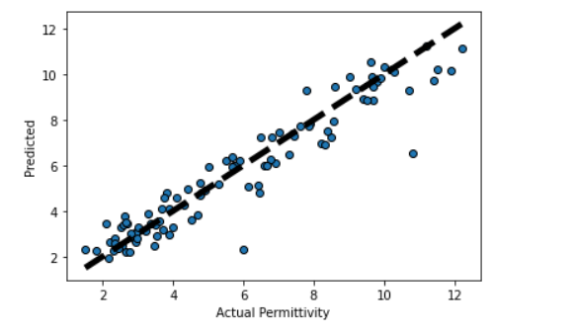

(b)

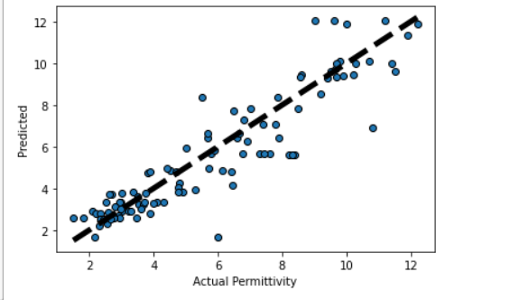

(c)

Figure 4.2: Total prediction accuracy. (a) Linear Regression, (b) Random Forest, and (c) SVR linear and RBF kernel

Table 4.1: Performance metrics for each regression model

|  |  |  |
| --- | --- | --- |
| Model | RMSE | R2 |
| Linear Regression | 0.67 | 0.84 |
| Random Forest | 0.82 | 0.83 |
| Decision Tree | 1.34 | 0.81 |

After applying each model individually, the results of all three models need to be combined for the accurate prediction of permittivity range. For this purpose, voting regressor was used. A voting regressor is an ensemble meta-estimator that fits several base regressors, each on the whole dataset. Then it averages the individual predictions to form a final prediction.Incorporating voting comes with many advantages. Firstly, since voting relies on the performance of many models, they will not be hindered by large errors or misclassifications from one model. A poor performance from one model can be offset by a strong performance from other models. Regression models built with voting take the predictions of each model and compute their average value to derive a final prediction. Figure 4.3 shows the overall prediction performance using voting regressor. Table 4.2 shows the overall prediction performance of the combined model.

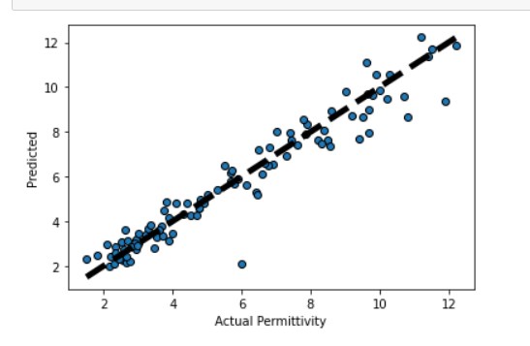

Figure 4.3: Overall prediction performance using voting regressor

Table 4.2: Overall prediction performance metrics

|  |  |  |
| --- | --- | --- |
| Combined model performance using voting regressor | RMSE | R2 |
| 0.73 | 0.82 |

**4.3.1 Regularization**

Regularization is a technique used to reduce the errors by fitting the function appropriately on the given training set and avoid overfitting. Overfitting is a phenomenon that occurs when a machine learning model is constraint to training set and not able to perform well on unseen data. The performance of an estimator on unseen data (test data) is not the same as the performance on training data. As the regularization increases, the performance on train decreases while the performance on test is optimal within a range of values of the regularization parameter. As regularization parameter increases from zero to infinity, the residual sum of squares in linear regression decreases, variance of model decreases and bias increases. Figure 4.4 and figure 4.5 show the performance vs. regularization parameter and train error vs. test error performance respectively

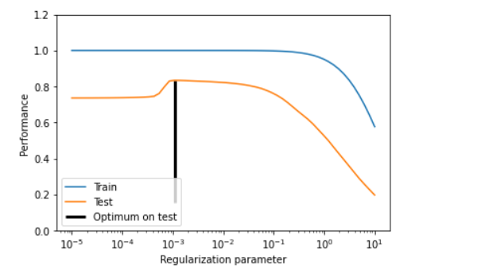

Figure 4.4: Performance vs. regularization parameter

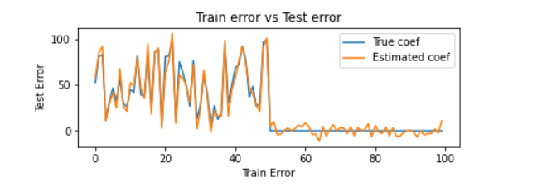Figure 4.5: Train error vs. test error

The overall prediction performance showed 0.73 RMSE and 0.82 R2 value. Cross validation and regularization measures were taken to make sure the model does not overfits on the data and the accuracy of prediction on unseen data is maintained. On testing the model for a random set of input, the results showed close agreement between the predicted value and the

actual value. Figure 4.6 is frequency vs. permittivity plot showing the permittivity range predicted by the model and the actual permittivity of the material. The blue lines indicate the range of permittivity predicted by the combined model and the cross symbols indicate actual permittivity.

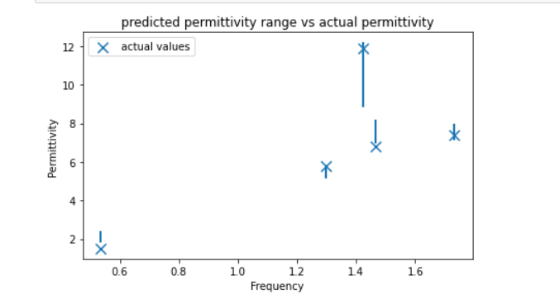

Figure 4.6: Plot showing the predicted range and the actual value of permittivity

**CHAPTER 5**

**CONCLUSION AND FUTURE SCOPE**

This project focused on the concept of microwave sensor array and the application of machine learning for predicting the permittivity of the material. Initially, the sensor design as given in the base paper was implemented to reproduce the same results. Thereafter certain modifications were made to get a more compact sensor array while maintaining the same S parameters. In the next step, the sensor array was simulated with several materials available in the CST materials library. The permittivity of the material under test and the resonant shifts in the five sensors were recorded to build the dataset. Machine learning was then applied on this dataset to predict an accurate range for permittivity of the material utilizing the resonant shifts of all five sensors as the input feature. A combination of linear regression, random forest and decision tree was applied to predict the upper bound and lower bound values of permittivity for a material. The results showed consistent performance of the ML algorithms in predicting the permittivity range of the MUT.

The various limitations of this project includes lack of physical experimentation and measurements, limited dataset and limited testing. The permittivity of MUTs used for training and testing the ML algorithms was limited to a range of 1.5-12.2. In future work, experimental validation of the said design can be performed, the range of permittivity can be expanded and a larger number of samples can be collected which can further improve the performance of the overall system and this approach can then be used as an automatic technique for predicting the permittivity of materials which is frequently needed in quality control in materials science, in food industry, bio sensing, or subsurface detection.

**REFERENCES**

1. Harrsion, L.; Ravan, M.; Tandel, D.; Zhang, K.; Patel, T.; K. Amineh, R. Material Identification Using a Microwave Sensor Array and Machine Learning. Electronics 2020, 9, 288. https://doi.org/10.3390/electronics9020288
2. Boybay, MS; Ramahi, Material Characterization Using Complementary Split-Ring Resonators, IEEE TRANSACTIONS ON INSTRUMENTATION AND MEASUREMENT, VOL. 61, NO. 11, NOVEMBER 2012.
3. Chuma, E.L.; Iano, Y,; Fontgalland, G,; Roger, L.L.B. Microwave Sensor for Liquid Dielectric Characterization based on Metamaterial Complementary Split Ring Resonator. IEEE Sensors Journal 2018, 18, 9978-9983.
4. Ansari, M.A.H.; Jha, A.K.; Akhtar, M.J. Design and Application of the CSRR Based Planar Sensor for Non-Invasive Measurement of Complex Permittivity. IEEE Sens. J. 2015, 15, 7181-7189.
5. Zhang, K., Amineh, R. K., Dong, Z., & Nadler, D. (2019). Microwave sensing of water quality. *IEEE Access*, *7*, 69481-69493.